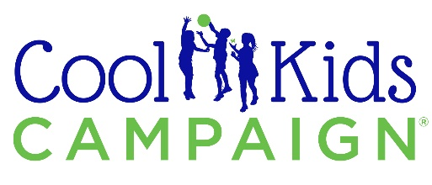

Note: For tax purposes, the value of the meal, including beverages, is estimated to be $XXX per person. When buying auction items, the value listed is an estimate of fair market value. The amount you pay above this fair market value estimate is normally tax deductible as a charitable contribution. The Raffle and wine pull are not tax deductible. All attendees, donors and contributors are encouraged to consult a tax adviser to clarify amount of deduction.

- Insert any additional rules or instructions here.

EXPRESS PAY
- For your convenience, you may register for Express Pay when you arrive at the Gala. This will speed up your checkout at the end of the evening.
- Simply present your credit card to a registration volunteer.
- Please allow 30 minutes after the silent auction bidding has closed before reporting to the cashier.

ORG Tax ID#: 12-3456789
«Bid_Card_Number»
- Dates for all trips and similar events must be mutually arranged with the donor. All reservations should be made at least 60 days in advance.
- Please note all airfare tickets included in travel packages are for coach travel. Airline blackout dates apply to all tickets, regardless of airline, and are subject to change. Tickets cannot be reissued or refunded.
- All completed sales from this event are considered transactions solely between the purchaser and the donor of the auction item.
- All gift card usage is the responsibility of the buyer. Although the gift card and amount are currently valid, ORG is not responsible for unused gift cards at businesses that may cease to operate before the expiration or usage date.
- No statements contained in the program or made orally at the sale or elsewhere shall be deemed an assumption of liability.
- ORG reserves the right to withdraw any item from sale.
- Items depicted in the slide presentation are for illustration purposes and may not be of the actual item.
AUCTION RULES
- Bidding on the Silent Auction items and Raffle will be on your smartphone or at the tables. The Silent Auction will close after the INSERT presentation.
- All bids are final and non-retractable. There will be no exchanges or refunds unless otherwise specified.
- ORG has attempted to describe and catalog items correctly, but in no event shall be responsible for the correctness of descriptions, genuineness, authorship, provenance or condition of the items.
- Please pay careful attention to all conditions, restrictions and expiration dates on items and services. Unless otherwise noted, restaurant certificates do not include alcohol, tax, or gratuities. We appreciate your strict observance of these restrictions, as future donations depend on it.
- Please make payments in full this evening. We accept cash, check, Discover, Visa, MasterCard and AmEx.
- The purchaser must pick up all items the night of the auction, unless special arrangements are made. Any item left unclaimed, without prior arrangements, will be sold and proceeds will go to ORG.
«Salutation» «Last_Name»
Bidder Number: «Bid_Card_Number»
Table «Table»

Iceland: Land of Fire and Ice
Donated by: XYZ Company
Iceland’s dramatic natural wonders are nothing short of magical. This adventure of a lifetime includes a 5-night stay at a 4-star hotel in Reykjavik with daily breakfast, airport transfers, Northern Lights by boat (mid-September to mid-April), guided tour of Reykjavik, access to Blue Lagoon geothermal spa, Golden Circle Tour of famous attractions, and South Coast guided walking tour of Reykjavik city center, plus Winspire booking & concierge service.
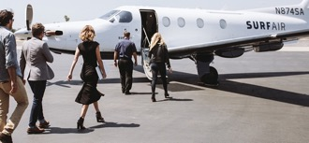
Premium Flight Service
Donated by: XYZ Company
Welcome to the future of flying! Surf Air, an alternative to commercial travel, saves its members 2 hours on every trip. Get one twelve-month Pay-As-You-Fly Surf Air membership with dedicated concierge, invites to exclusive Surf Air membership events, and up to 3 companions listed under your membership; four complimentary one-way flights on Surf Air's California route network; and waived initiation fees for an All-You-Can-Fly membership upgrade.
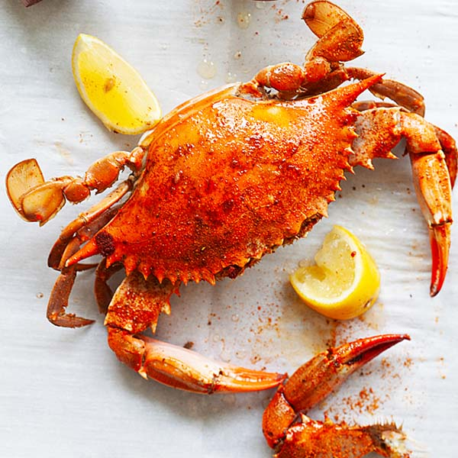
Maryland Crab Feast
Donated by: Mr. & Mrs. ABC
Break out the Old Bay and enjoy an all you can eat Maryland crab feast for 12 on the shores of the Chesapeake Bay. Experience the camaraderie and imagine yourself enjoying the freshest seafood with local sides like red skin potatoes, corn on the cob, and plenty of desserts. The feast can be any day after 4:00PM from July- September. Bid last on this classic feast!
Lab

Sip & Soar through Napa Valley
Donated by: XYZ Company
Peacefully float above the world-famous Napa Valley, taking in endless rows of vineyards and majestic mountains. Win a hot air balloon ride for 2 over Napa Valley with champagne brunch; private tour and wine tasting at Fontanella Family Winery and Jessup Cellars; 6 consecutive hours of chauffeured luxury sedan service; and 3-nights at the Meritage Resort and Spa.
* Please look at Mobile Bidding Provider / the auction catalog for restrictions on Live Auction items
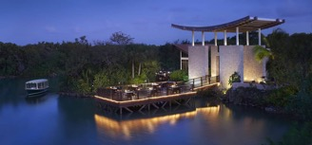
Banyan Tree Mayakoba 5-Night Getaway
Donated by: Mr. & Mrs. ABC
Explore the magic of Mexico, unwind on the golf course, or simply bask in the stunning coastline views at Banyan Tree Mayakoba, where romance and relaxation come together in Playa del Carmen. This 5-diamond luxury resort offers elegance, tranquility, and endless natural beauty. Lush villas with private swimming pools make for a romantic escape or a relaxing family getaway.
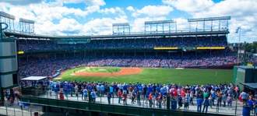
Classic Wrigley Field Rooftop Experience
Donated by: XYZ Company
Take part in a Wrigley Field tradition that goes back to the first Opening Day in 1914. Two people will enjoy a regular season Chicago Cubs game from a nearby rooftop with ballpark food and ice-cold beverages. A must-do for any baseball fan! Also included: 3-night stay at the Fairmont Chicago (Millennium Park) and daily breakfast for 2.
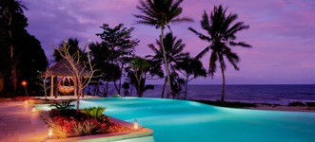
Fiji Paradise
Donated by: XYZ Company
Escape with family or friends in the luxury of The Auberge Beach Villas at Nanuku on Viti Levu, the most accessible island of Fiji. Enjoy a 7-night stay for up to 4 people in a 2-bedroom, 2-bathroom oceanfront villa at The Auberge Beach Villas including private plunge pool, courtyard garden and outdoor dining area, plus private round-trip ground transportation from Nadi Airport.
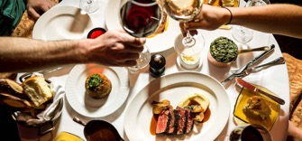
Ultimate Dinner Party for 8
Donated by: Hanna’s, Viola Violinist, XYZ Desserts
Plan the ultimate dinner party for 8 in your own home, catered by Hanna’s Steakhouse and serenaded by local musician Viola Violinist. You’ll also receive a custom, home-made dessert to share with your guests. Date and time to be mutually agreed upon with Hanna’s, violinist, and dessert donor. Catering expires December 1. Violinist performance valid through July 31.

Disneyland VIP Tour for 10
Donated by: XYZ Company
Get ready for the ultimate Disney experience: a Disneyland (Anaheim, CA) VIP Tour! Win one-day park hopper tickets for up to 10 people, a private tour guide to accompany your group for six hours, priority expedited access to 30+ attractions, reserved viewing for parades and nighttime spectaculars, access to character meet and greets and special photos.

